



WELCOME TO

RECOVERY COLLEGE

WELLNESS CENTRE







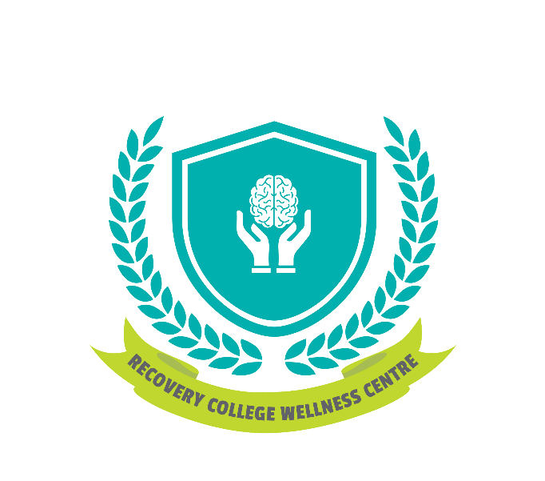

THE JOURNEY
IS YOURS
recoverycollegeandwellnesscentre@cmhadurham.org
Helping People Move Forward

905.436.8760 x 293

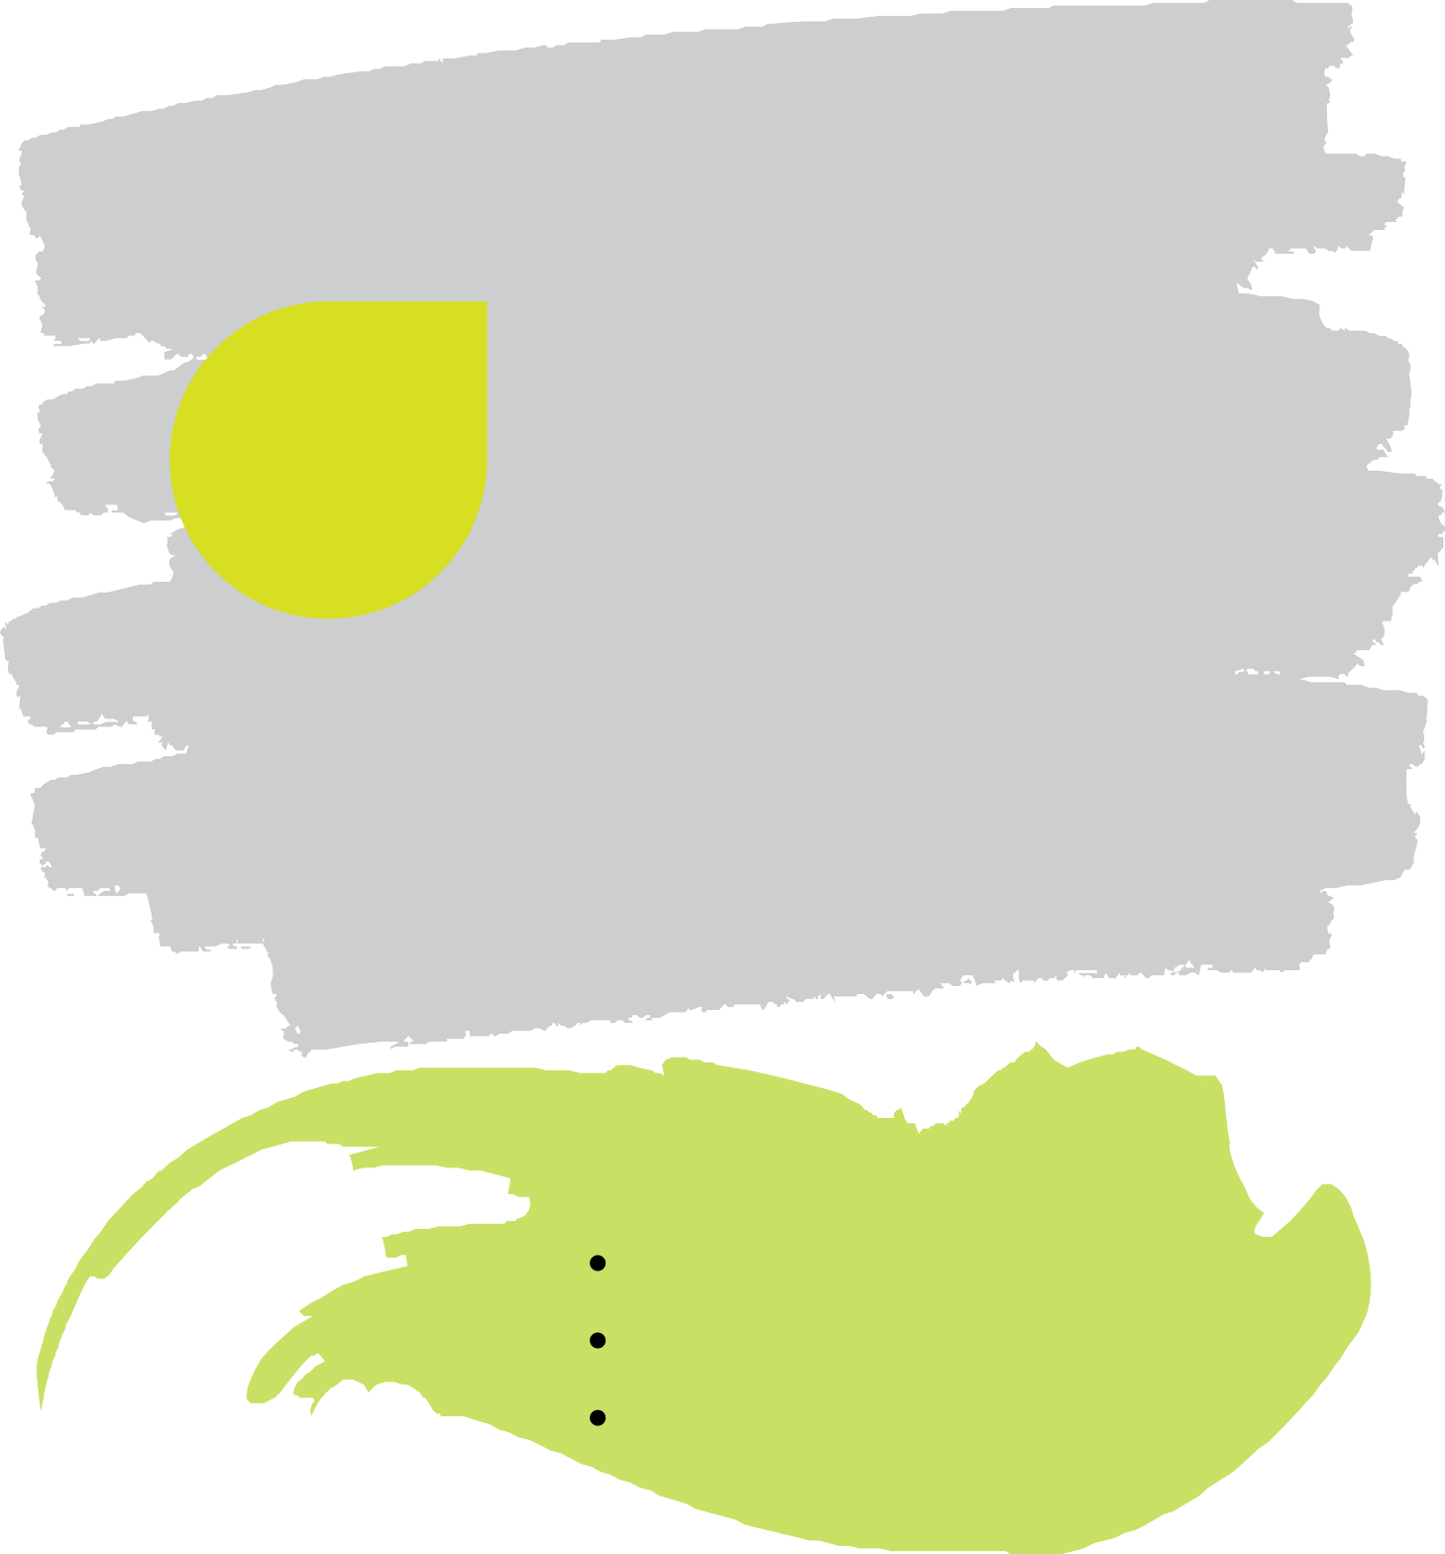

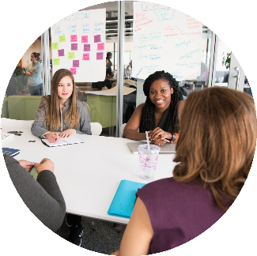


At Recovery College Wellness Centre, our educational-based approach focuses on helping people recognize and develop their own resourcefulness and awareness in order to support themselves or their loved one’s recovery journey. All our courses are developed and delivered in partnership with our Peer Supporters who are experts by experience. Each Peer Supporter has their own story of mental illness, substance use, or supporting a loved one.

WE OFFER

Customized SCHEDULE developed collaboratively with a staff member to fit your needs as best as possible.
Interactive COURSES that create positive learning experiences, emphasizes connection, hoping and belonging
PEER SUPPORTER led courses from individuals who are experts by experience

.

Winter 2021 Semester
Jan 4-Mar 26

Courses marked with * are available for this semester
In-class and on-line

Foundational Classes & Courses

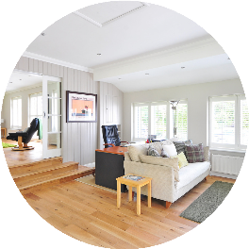

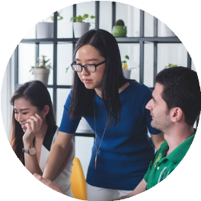
*Study Hall (in-person)
Study Hall is designed to be a quiet time for students to complete any homework, assignments, catch up on missed work or readings from previous classes, or connect with the Facilitator(s) for any clarification or questions. Students do not need to enroll in this course for the entire semester, but are asked to sign up weekly to reserve a spot. Seats are limited.
Co-Design
What makes the Recovery College Wellness Centre different from traditional Adult Learning spaces is that it is built on the foundation of Co-Design. Students, community members, staff, educators, & stakeholders all provide feedback, guidance, and participate in the construction of how and what is offered through the Recovery College Wellness Centre. This course is a cornerstone designed to enhance participation in and keep Co-Design at the forefront of all we do.

*Recovery Journeys (in-person and virtual)
All students are required to attend the Recovery Journeys course. Offered continuously throughout each semester, this course dives deep into the CHIME Framework, the pillars of personal recovery: Connectedness, Hope & Optimism; Identity, Meaning, Empowerment.

*RCWC 101 Information Session (in-person)
All persons interested in attending the Recovery Wellness Centre are asked to attend our RCWC 101 Information session. Here you will learn all about what the RCWC has to offer including detailed information about upcoming courses, the Peer Support Program, meet the team and find out how you can get involved right away. We offer this class bi-weekly on Thursday mornings.

School of Peer Support

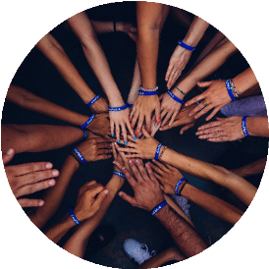
Peer Support Program
The Peer Support Program is available to anyone seeking to expand their knowledge/understanding of peer supports at CMHA Durham. This training will provide you with the skills, knowledge, and tools to be a Peer Supporter with the Recovery College Wellness Centre. Designed to take place in 2 modules over 12 weeks, you will have an opportunity to share your recovery story, learn how to communicate effectively, provide empathetic support, and gain employability skills.

Breaking the Code: Principles of Adult Learning
It’s important to understand the motivation behind why adults continue to learn and how they relate to their professional and personal development. Through discussions, demonstrations, group work, and independent studies, this course will explore the 8 principles of adult learning.

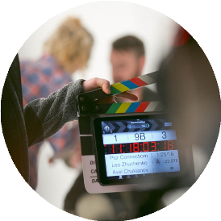
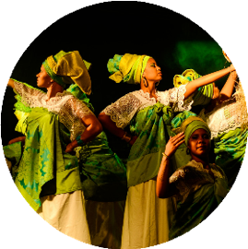
*The Art of Leadership (Virtual)
Leadership is for everyone. Interactive activities and engaging discussions will guide you in building key leadership and mentorship skills such as empathy, cooperation, communication and more. Whether you want to be more of a leader at work or mentor a friend this course will help you lay the foundation of improving your leadership and mentorship skills.

Facilitation 101: Adding the Secret Sauce
Discover the secrets that make adult classrooms, meetings, and group sessions impactful and interesting. This course will dive into the skills, techniques, tips & tricks necessary to make any facilitated group successful.

School of Life (Skills)



*Living Life to The Full (in-person)
Want to know how to feel happier, more confident and worry less right now? Would you like to learn new ways of dealing with what life throws at you? Living Life to the Full is a fun and interactive course that will help you understand your feelings, thoughts and behaviours, and what do about them!


Assert Yourself
Being assertive is an important communication skill which can reduce your levels of depression and anxiety and improve your self-esteem. This class is designed to provide you with some information about assertiveness – what it is, what stops us from being assertive and how to become more assertive.



Financial Literacy
If you are feeling stressed by your finances, you are not alone. This interactive course takes it back to the basics of budgeting, credit, debt and more to help you gain knowledge and confidence when it comes to your money.

RentSmart
Through the RentSmart certificate course, you will learn how to plan for housing; identify what landlords look for in choosing a tenant; improve your chances for getting the housing you need; learn how to improve your rental references and how to improve your credit rating. At the completion of the course you will receive a RentSmart certificate which lets landlords know you are serious about being a responsible tenant.

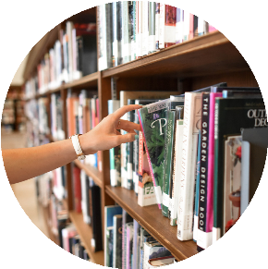
*Mindfulness (in-person)
Mindfulness is a proven technique that helps to reduce the affects of anxiety, depression, stress, and anger. In this 4 week course, you will learn what mindfulness is about, where it comes from, and practice techniques you can take anywhere.
*Organizing Ourselves to Maximize Time (Virtual)
The goal of this course is to get students started on a path to becoming more effective with how they use time. We examine and even challenge our perceptions of time, try to understand what is truly important to us, go through exercises in planning and prioritizing how we spend time to be effective and importantly, manage expectations of ourselves. At the end of this course students will have a framework within which to organize their week to be more effective, one that is based on Stephen Covey’s best selling self improvement guide – The Seven Habits of Highly Effective People.

School of Life (Skills)
Soft Skills Solutions ©
Learn about the skills you need to compete and advance in today’s job market. Taught by certified Soft Skills Solutions Trainers, the program covers important topics that will give you confidence and a competitive edge at your next job. Learn more about the key workplace skills employers are asking for: Communication; Teamwork; Personal Management; Problem Solving & Critical Thinking; and Professional Development.


School of Life (Skills)

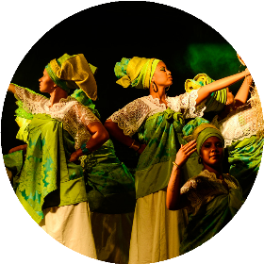

Sleep Hacks: Tips & Tricks for Better Living
This course is all about your personal care for well-being and a disciplined life-style. It will focus on healthy sleep, sleep hygiene, self-care, Circadian Yoga and Meditation all with the hopes of helping you get a better night’s sleep.

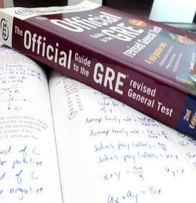
*Up Skills for Work © from ABC Life Literacy Canada (Virtual)
Soft skills help workers to be adaptable and motivated throughout their whole employment and as they move into new roles or careers. In other words, they lay the foundation for a strong and flexible workforce and for happy, fulfilled workers.
This course helps learners develop 9 key employability skills: Motivation; Attitude; Accountability; Presentation; Teamwork; Time Management; Adaptability; Stress Management; & Confidence.

Understanding Media during COVID-19 and Beyond
COVID-19 has has flooded our news outlets and social media pages. With so much information being shared and information changing every day it can be difficult and stressful to keep up. How do we know what we are reading and hearing is in our best interest? Media Literacy During COVID-19 and Beyond is an interactive and reflective 3 part webinar that will guide you through understanding the media and develop skills to determine fact from fiction.


Coping with Change Fatigue Workshop
COVID-19 is creating one of the biggest changes many of us will experience. The changes are not just happening within our homes but within our communities, country, and internationally. This workshop will guide you in how to take back control during this unprecedented time of change.

School of Social & Recreational Support

Hello French! Bonjour Francais! (French Café)
Learning a new language has proven to enhance brain function and reduce the burden of brain related diseases such as Alzheimer’s. At the French Café, students have an opportunity to discuss varying topics pertaining to health & wellness, while learning French in a fun, comfortable environment. The French Café will also incorporate nutrition and food prep for immersion in French cuisine where students can learn the basics of French cooking.

*Support Group (in-person)
Come join us for our weekly support group where every conversation matters. This course allows you to discover peer support, build friendships and communication skills. Topics vary from week to week.

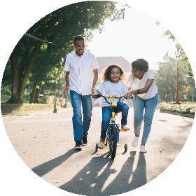
Field Trips
Join this group if you would like light to moderate physical activity. Focusing on mindfulness and appreciation for nature and recreation, this course aims to help with social skills as you explore local trails and parks together. Look for a fun, low-cost outing at the end of the course!

*The Muse in Music (Virtual)
Music and lyrics have a way of universally communicating shared experiences and bringing people together. This course looks at lyrics and music of popular songs and how they affect us emotionally, mentally, and even physically. Together you will discuss, discover, and share the power of song.
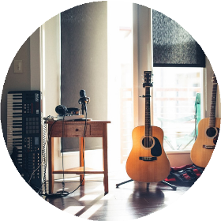

*Yoga with Warrior Yoga (virtual)
These classes are for anyone looking to finally feel comfortable in their own skin, who want to make friends, & beginners to Yoga. Students will learn how basic movements can create ease & strength within the body & how to control the breath in any situation on or off the mat. This is a basic intro to Yoga where touching your toes is not a prerequisite. Every BODY can do Yoga!


Paint Class
Have you ever wanted to create a work of art, but lacked the confidence and experience? Look no further! This Peer-Led class will walk you through 4 different art pieces. With step-by-step instruction, you’ll have no trouble mastering the fine art of painting.

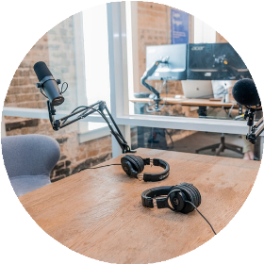
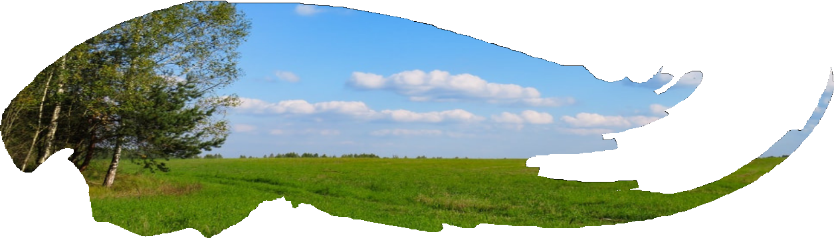

School of Social & Recreational Support

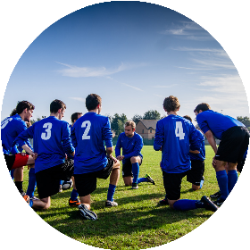
Games Group
Join us for a fun time learning social and personal skills together using a variety of games. Any game level of complexity is welcomed. From cards to Dungeons & Dragons, we will embark on an epic games quest together!




Karaoke
Do you love to sing? Do you love listening to people sing? Then this group is for you! No talent is necessary, just a love of music!

*Bibliotherapy (virtual)
This course is designed around themes, such as hope, love, resilience, & fear. Together you review book excerpts, quotes, articles, short stories, and other written prose that explore the theme and share insights and perspectives.

*Couponing (in-person)
Are you looking for ways to save money and extend your grocery budget? Look no further! This weekly course is led by our resident couponing guru who will share with you tips, tricks, and websites to help you cut down that grocery bill. Join the wild and wonderful world of couponers now!

School of Clinical Studies

WRAP
The Wellness Recovery Action Plan or WRAP Workshop is a self-designed prevention and wellness process that anyone can use to get well, stay well and make their life the way they want it to be. WRAP workshop will help you discover simple, safe wellness tools to help you overcome mental health issues and move on to fulfilling your life dreams and goals.

Dialectical Behaviour Therapy Skills Group: Building a Life Worth Living
This Dialectical Behaviour Therapy (DBT) Skills Group will provide you with the skills to build a life you want to be a part of. Together, we will learn skills to help you better cope with stress and crisis, gain better control over your emotions, improve your communication skills and develop mindfulness of yourself and your environment.


*Art Therapy (virtual)
In art therapy sessions, making pretty art is not our goal and Art Therapists do not teach individuals how to make art. Art Therapy is a way to express oneself using a creative process. It helps in expressing feelings; provides a sense of control; is a coping skill; reduces pain & anxiety; helps with self-awareness & discovery; and manages stress & helps with relaxation.

Addiction Support Group
Struggling with addiction? New to sobriety? Our informal Addiction Support Group will guide you in building key personal strengths such as combating cravings, understanding triggers, identifying coping skills, setting goals, and more. In addition to this, you will have the opportunity to engage in meaningful discussions on relapse management/prevention, the importance of mindfulness in recovery, and personal experiences which will provide support and feedback through interactive activities. Whether you want to learn new skills to reduce your substance use, or maintain your sobriety, this course will help you achieve your goal by preparing you with the essential tools to be successful.

*Understanding Common Mental Health (in-person)
In this course you will learn to identify the differences between mental health and mental illness while also being able to identify the different mental health disorders and what characteristics define them. This course will also explain what a mental health advanced directive is and why it is important for all clients to create one for their crisis plan. Through group discussion, activities and online resources you will discover why mental health matters to you and those in your community.

*Explorations of Music Therapy (virtual)
Run by a licensed Music Therapist, the purpose of this course is to experience the various foundations of music therapy through focus on therapeutic activities and explorations. Through online small group activities, participants will have the opportunity to learn the therapeutic use of music in different capacities and delve into personal relationships with music. Activities will include components of song analysis/discussion, song writing, music and imagery, and interactive music making.
Tolerance for Uncertainty
Are you, like so many others, feeling anxious about all the unknowns of this pandemic? Are you feeling exhausted from the constant newsreels, projections, estimations, and general uncertainty? This course is built around a workbook created by Dr. Sachiko Nagasawa. It will take you through some self-care tips, stress management, DBT skills, and self-compassion exercises to help build your resilience.

School of Clinical Studies


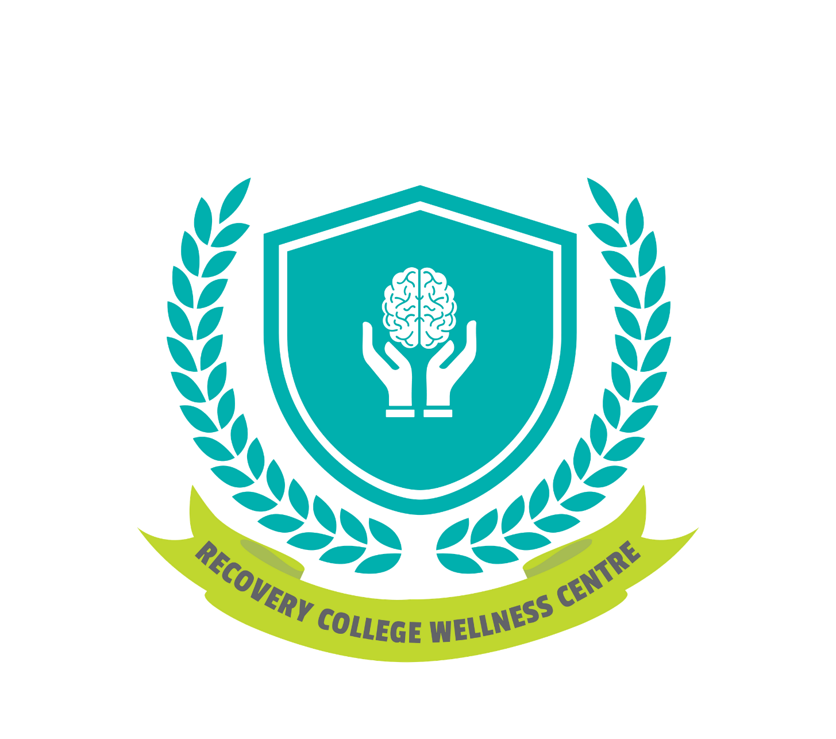


REGISTER TODAY

905.436.8760

recoverycollegeandwellnesscentre@cmhadurham.org

60 Bond St W, Oshawa ON
L1G 1A5
Co-design Program development and implementation

